**Using else with the if statement**

In all the if statements shown above there are no statements along the false branch. If we need to execute statements if the condition is false then we have to use the optional else clause as follows:

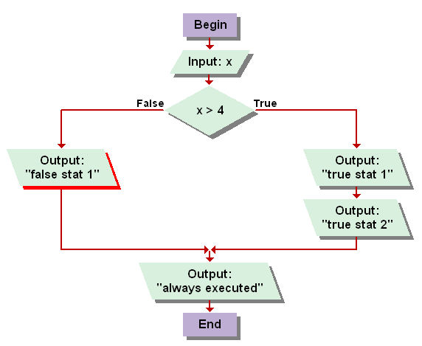

System.out.println ("Enter a value: ");

int x = scan.nextInt();

if (x > 4)

{

System.out.println ("true stat 1");

System.out.println ("true stat 2");

}

else

System.out.println ("false stat 1");

System.out.println ("last statement");

If the condition is true (i.e. x > 4)

Output: true stat 1, true stat 2, always executed

If the condition is false (i.e. x <= 4)

Output: false stat1, always executed

The same curly braces rules apply to the else clause. It works with only one statement. If more than one statement is needed then curly braces must be used.

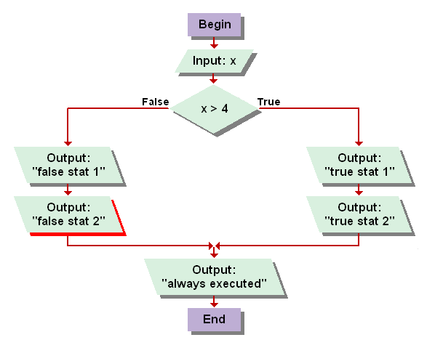Example:

System.out.println ("Enter a value: ");

int x = scan.nextInt();

if (x > 4)

{

System.out.println ("true stat 1");

System.out.println ("true stat 2");

}

else

{

System.out.println ("false stat 1");

System.out.println ("false stat 2");

}

System.out.println ("last statement");

I am sure you know the output of the above code.